Main workshop

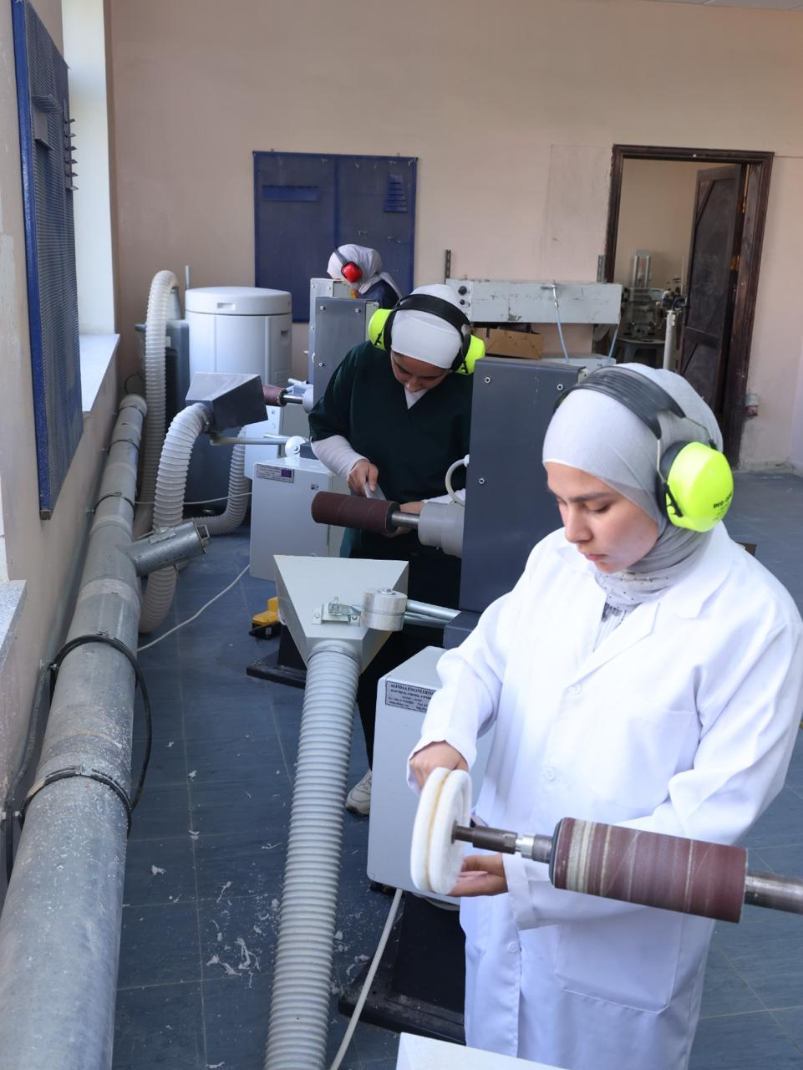

Students perform trimming and finishing procedures using laboratory equipment as part of the practical training in the fabrication of prosthetic and orthotic devices.
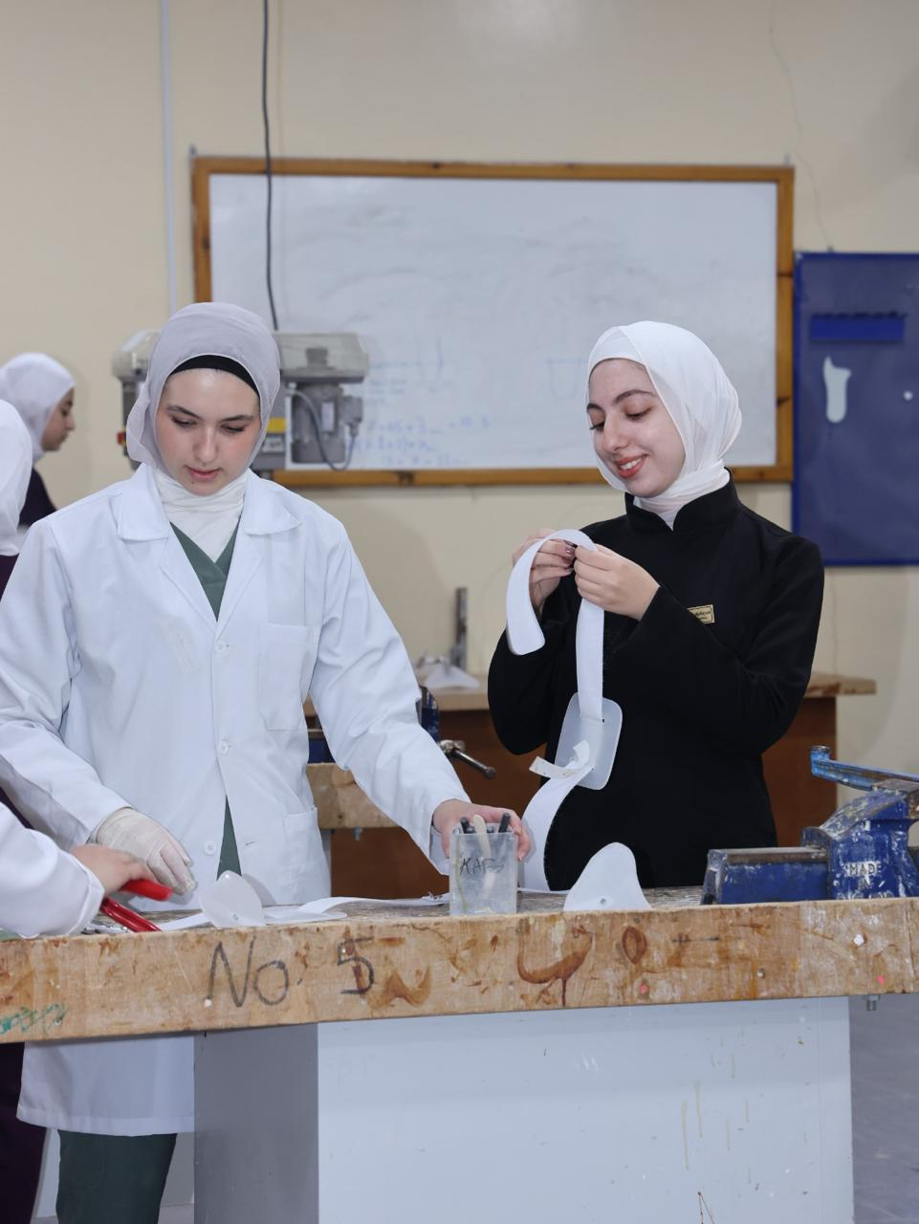

Female students work on preparing and cutting plastic materials as part of the practical training in the prosthetics and orthotics laboratory.
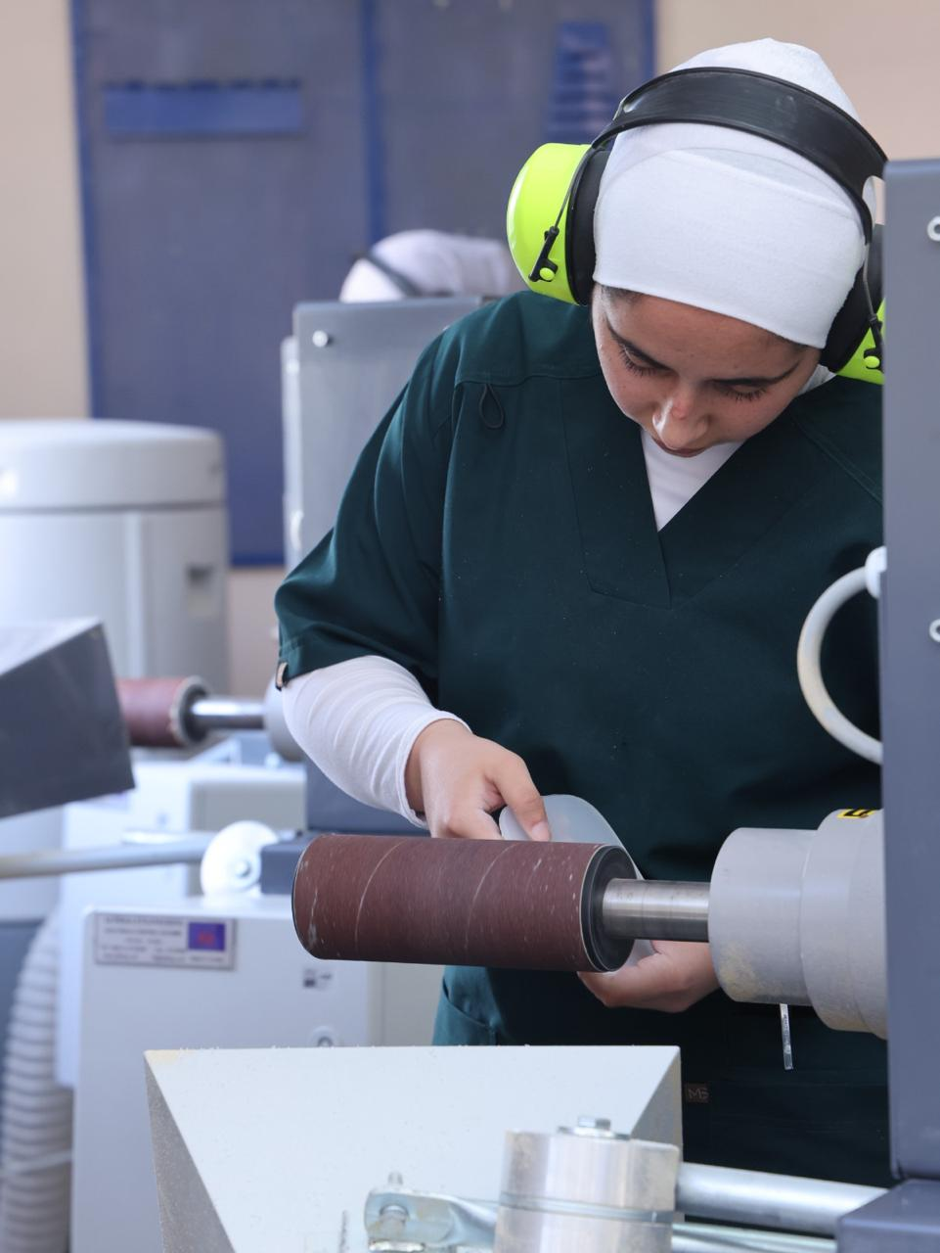

A student performs smoothing and finishing of materials using the sanding machine as part of the practical training in the fabrication laboratory.

